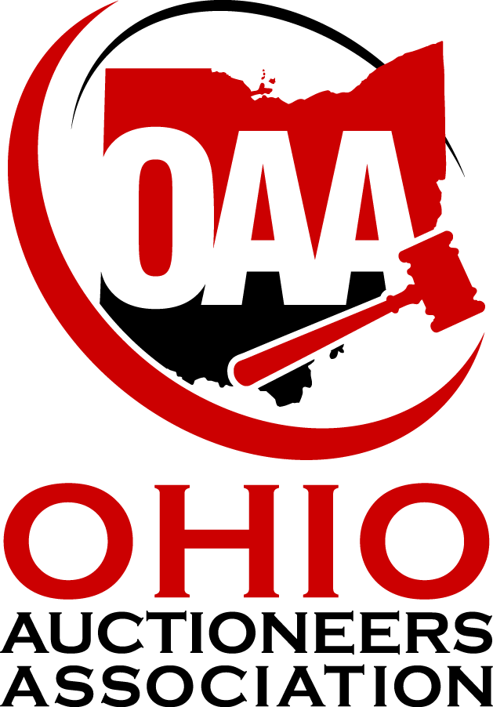

Public Policy Agenda
2015

Draft January 10, 2015

Adopted January 16, 2015

BUSINESS PRACTICES, PROFESSIONAL STANDARDS, EDUCATION AND GOVERNMENT REGULATION
We reaffirm our commitment to complying with both the letter and spirit of all state, local, and federal laws regulating the auction industry, and pledge our support and assistance in the further development of policies and programs which ensure the continued integrity and viability of the auction industry while offering adequate protection for the consumer.
We support government regulations which strike a balance between necessary regulations to protect the integrity of the industry and the health, safety, and well-being of the public while ensuring that the concept of free enterprise without undue government intervention is maintained.
We support the creation of a strong base for continued economic development and the creation of jobs in the State of Ohio and the modification of governmental legislation and regulations to that end. We affirm the need for Ohio to develop an environment more conducive to retaining and attracting businesses to the State.
We support a viable and responsible education system based upon equitable and sustainable funding sources and the State of Ohio fulfilling its constitutional mandate.
In addition, we reaffirm our commitment to and belief in the Ohio Auctioneers Code of Ethics and the Standards of Practice contained therein.
We urge government officials at all levels to solicit the input and expertise of the auction industry in formulating government regulatory policies.
Sale of Titled Vehicles, Farm Machinery and Heavy Equipment on Consignment
We support any effort that allows individuals, institutions or businesses to consign titled vehicles, farm machinery and heavy equipment to a public auction without regard to the number of vehicles, age of the vehicles, reason for sale or physical size of the auction venue. We believe there should be a free market for all titled vehicles, farm machinery and heavy equipment in Ohio to promote and maintain positive growth and trade.
Continuing Education
We support ongoing investigations into the viability, necessity and appropriateness of auctioneer continuing education.

Auctioneer, Bid Calling and Related Contests and Events
We seek relief from the enforcement of ORC 4707 with regards to annual Auctioneering or Bid calling contests held by the Ohio Auctioneers Association and any future events held by other state or national auctioneering associations or related identities. These events are positive promotion of the Ohio Auction Industry and with approval by the Ohio Auction Commission should be allowed to occur without further licensing or regulation.
Foreclosures and Sheriff Sales
We support legislative and regulatory efforts to modernize and privatize the sale of Real Property as a result of a foreclosure. We believe that licensed Ohio Auctioneers and Real Estate Salespeople or Brokers marketing and selling property in the foreclosure setting is in the best interests of all parties and communities.

Online Auctions

Recognizing the distinct difference between those selling as individuals, and those who engage in the professional practice of auctioneering; and given the apparent frequency of online auction fraud and the lax governmental oversight of online auctioneers, the OAA recommends that Ohio license and regulate online auctions and auctioneers under modified forms of existing state law.

The differences between online auctions and traditional auctioneers are minimal. The only significant difference between the two is the choice of medium.

The OAA believes the lack of regulatory oversight of online auctioneers constitutes an unfair advantage over traditional “brick and mortar” auctioneers. At a minimum, state-licensed auctioneers must demonstrate their knowledge of applicable state laws; contribute to recovery funds or hold a bond; pay applicable licensing fees; and adhere to professional standards set by law. In contrast, online auctioneers do not currently have to meet this burden of demonstrating their knowledge of regulation, nor do they have to adhere to a standard of conduct.

However, the Ohio’s regulation of the auction industry is not overly burdensome. As written, state regulations accomplish two goals. First, the statutes outline the professional responsibilities and duties for an auctioneer. Second, these regulations protect the consumer, both bidder and seller. The majority of license law applicants must first undergo a criminal background check, and individuals convicted of felonies are barred from conducting auctions. Licensing laws also mandate auctioneers meet minimal educational requirements (high school diploma or equivalent) and age requirements. Consumers with grievances against an auctioneer can seek restitution from a states’ recovery fund or have their losses applied against an auctioneer’s bond.

It is our belief that those individuals who conduct auctions on the Internet should be licensed in the state in which they reside. This would include those individuals who conduct such sales on consignment, who purchase property expressly for resale through such venues, or businesses that offer merchandise for sale through online auctions.

Current licensing laws should be interpreted to include online auctions. But, they should be interpreted so as not to place an undue burden on online auctioneers, and in some cases modified to better suit this new medium. Some requirements—knowledge of bid calling practices and course of study at an accredited auction program or apprenticeship—are simply not practical for online auctioneers. Waiver of these requirements or additional legislation would lessen any undue restrictions on online auctioneers.

Sales Taxes on Services

Ohio Auctioneers oppose sales and use taxes on services or commissions. An auction transaction is already subject to double taxation when one considers the transfer taxes paid at conveyance and the income tax paid by an Auctioneer on the commissions they earn annually. Adding another layer of tax further erodes the ability of an Auctioneer to contribute to the economic growth of the region.
We stand ready to support efforts to educate our members about the impact that any potential changes to the tax structure represent.

